**Most Recent Stewardship Figures:**

**Our Presence**

8:30am (Traditional) 55

11:00am (Contemporary) 28

11:00am (Traditional) 66

Viewed live online (Traditional) 30

Viewed live online (Contemporary) 6

Views (Traditional) 28

Views (Contemporary) 31

Vespers (Next Vespers 7/21/21) 0

Total: 244

**Our Gifts**

Received: $17,631

Needed Weekly $20,622

Budget Goal to date $556,794

Receipts to date $427,279

Expenses to date $465,663

Over/Under (revenue vs. expenses) **-$38,384**

**Our Service**

***Children’s Church:*** Katy Handell, Heather Connor

***Nursery (11:00am):*** Linda Gladden, Liz Roland

***Children’s Message:*** Lori Meyers (11:00am Trad.)

***Acolytes:*** Ben Moore (8:30)

Mary Scott Handell (11:00am)

***Ushers:*** Susan Matthews, Daisy Hicks, Terry Hicks, John Cooper, Mike Mitton, John Stewart, Rick & Stephanie Thain, Sam Owens

Our Calendar

Sunday, July 11

8:30am Traditional Worship (LUMC Sanctuary)

9:45am Sunday school (SS Rooms)

11:00am Contemporary Worship (Wesley Hall)

11:00am Traditional Worship (LUMC Sanctuary)

5:30pm Youth Come to the Water (Golden Hills Pool)

Monday, July 12

9:00am Preschool Camping Camp (Preschool Hall)

10:30am Exercise Class (Wesley Hall)

2:00pm Red Cross Blood Drive (Asbury Hall)

Tuesday, July 13

9:00am Preschool Camping Camp (Preschool Hall)

10:00am Staff Mtg. (Asbury Hall)

5:00pm H.S. Youth Arcade Time (off site)

5:30pm Al-Anon (Parlor)

Wednesday, July 14

6:30am Men’s Wed. Prayer Group (Asbury Hall)

7:30am Walking Warriors (Gibson Soccer Park)

9:00am Preschool Camping Camp (Preschool Hall)

10:00am M.S. Youth Bubble Soccer (off site)

10:30am Exercise Class (Wesley Hall)

Thursday, July 15

9:00am Preschool Camping Camp (Preschool Hall)

10:00am Line Dancing (Wesley Hall)

2:00pm Senior Card Playing (Asbury Hall)

Friday, July 16

7:00am Centering Prayer (MC106)

7:30am Walking Warriors (Gibson Soccer Park)

10:30am Exercise Class (Wesley Hall)

1:00pm Stepping Stones (Outside by playground)

6:30pm Worship Band Practice (Wesley Hall)

Saturday, July 17

M.S. Mission Trip to Memphis, TN

Sunday, July 18

M.S. Mission Trip to Memphis, TN

8:30am Traditional Worship (LUMC Sanctuary)

9:45am Sunday school (SS Rooms)

11:00am Contemporary Worship (Wesley Hall)

11:00am Traditional Worship (LUMC Sanctuary)

CAN YOU GIVE?

While we normally discuss giving in the context of our pledged tithes and offerings for the next year, our current financial position requires us to address giving right now. As of Sunday, 7/4/21, our expenses are now exceeding our receipts by $38,384. In order to continue our ministries, we need everyone’s help. If you made a pledge for giving in 2021, please do your best to be current in your giving. If you didn’t pledge for this year, please prayerfully consider an offering at this time. Your faithfulness in sharing your time, talents, and resources is a testimony to God’s faithfulness to us, and we give thanks for that!

Cards, Anyone?

The LUMC Seniors will resume their weekly card playing every Thursday from 2pm until 4pm, beginning July 8th! Doors will open at 1:45pm. All games will be played in Asbury Hall. Masks are recommended if you have not been vaccinated.

Middle School Trip

Please be in prayer for safe travels for our middle schoolers who will be traveling to Memphis, TN this week for mission work!

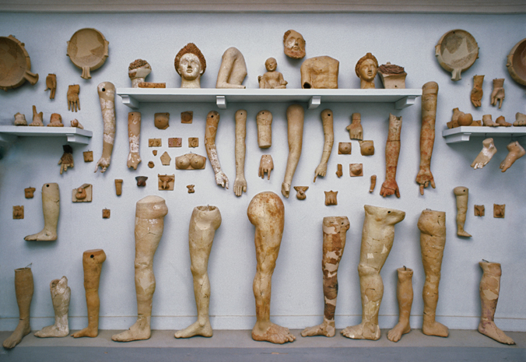



***July 11, 2021***

**Weekly Worship Opportunities:**

**8:30am – Traditional Sunday Service (LUMC Sanctuary)**

**11:00am – Contemporary Sunday Service (Wesley Hall)**

**11:00am – Traditional Sunday Service (LUMC Sanctuary)**

**6:30pm – Third Wednesday Vespers (LUMC Sanctuary)**

**Church Office: 803-359-6838** [**www.lexumcsc.com**](http://www.lexumcsc.com)

“Making disciples for the transformation of the World”